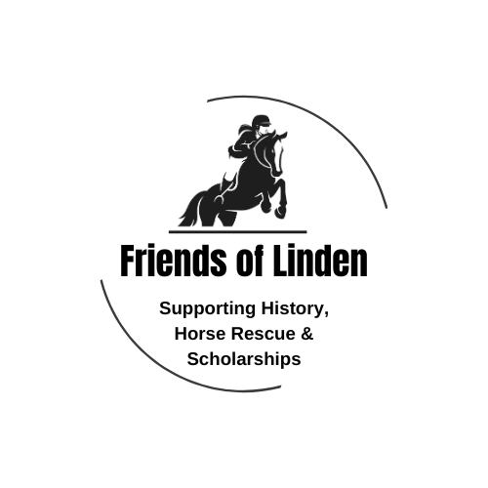

2024 Linden Hunter Show Series Sponsorship

We need your support to make this show series and the end of the year banquet a success. The riders work so hard to prepare for the series and we want to celebrate their achievements.
Please select your sponsorship level:
- $250–Year End Division (supports trophy, plaque, rosettes), will receive a ½ page ad or message in the banquet program
- $100–Supports one class in one show, will receive 1/3 page ad or message in the banquet brochure
- $___________ (choose your donation amount)

- Item Donation-We are looking for items for our silent auction at the banquet. What is the item you are wiling to donate: __________________________________ Value: $_____________
All sponsorship levels will have their name displayed on the photo show during the banquet.
---------------------------------------------------------------------------------------------------------------------
Payment Details
Please send this form along with your ad/message to: lindenfarm2000@gmail.com
Make checks payable to: Friends of Linden – La Plata
Venmo:
Paypal: lindenfarm2000@gmail.com

Sponsor Name: ________________________________________________________________

Amount Paid: $__________________________ Ad/Message enclosed? _____ Yes _____ No

